Semantic Segmentation of Satellite Imagery for Land Cover Classification
¹C. Dastagiriah, ²G. Sreeja, ³T. Santosh Bhargava, ⁴V. Tharun Raj, ⁵B. Koustubh Srivatsa

¹Assistant Professor, Department of Computer science and Engineering, Anurag University, Hyderabad, Telangana – 500088, India.
²Department of Computer science and Engineering, Anurag University, Hyderabad, Telangana – 500088, India.
³Department of Computer science and Engineering, Anurag University, Hyderabad, Telangana – 500088, India.
⁴Department of Computer science and Engineering, Anurag University, Hyderabad, Telangana – 500088, India.
⁵Department of Computer science and Engineering, Anurag University, Hyderabad, Telangana – 500088, India.

¹@cvsr.ac.in
²21eg105b52@anurag.edu.in ³21eg105b55@anurag.edu.in ⁴21eg105b59@anurag.edu.in ⁵21eg105b61@anurag.edu.in

Abstract- Accurate classification of high-resolution satellite imagery is essential for various socio-economic and environmental applications, including urban planning and natural resource management. This study proposes an enhanced U-Net architecture integrated with a Spatial Pyramid Pooling (SPP) layer to improve pixel-level semantic segmentation of satellite images. The traditional U-Net model often loses critical object boundaries during pooling operations, which can hinder classification performance. By incorporating SPP, which captures multi-scale contextual information, the proposed model retains spatial details and enhances the ability to differentiate between similar land cover types. Experimental results on two public datasets demonstrate that our improved model outperforms existing algorithms trained with various datasets in terms of classification accuracy and boundary preservation.

Keywords: - Satellite image classification, Deep Learning, U-Net, Spatial Pyramid Pooling, Semantic Segmentation.

INTRODUCTION
The increasing need for current information about the earth’s surface is driven by its essential role in various applications such as global, regional, and local resource monitoring, as well as the tracking of changes in land cover and land use for geographical and environmental research [1]. Satellite image classification is essential for many socio-economic and environmental applications of geographic information systems, including urban and regional planning, conservation, and management of natural resources, etc. During the last decades, great efforts have been made in developing approaches to infer land usage from satellite images (Gong et al., 2015). Deep Learning has shown high accuracy in computer vision tasks and has high potential to handle the growing amount of Earth Observation (EO) data in an automated process. For generating land cover classification maps an image segmentation task needs to be solved. Pixel level segmentation on satellite images is challenging because collecting a ground truth dataset for training such a segmentation model is difficult and time consuming [2]. However, it is still one of the most challenging problems for automatic labelling high spatial resolution satellite images at the pixel level due to the high intraclass and low interclass variabilities presented in the images.

Satellite image semantic segmentation is a pixel- wise classification task for a satellite image. Semantic segmentation expresses the way of identifying each pixel of a particular image along with a class label, such as road, building, land, water, or vegetation and unlabeled. Satellite image segmentation, used to locate objects and boundaries in images (straight lines, curves, etc.), refers to the division of a digital image into multiple pixels sets [3], enabling detailed analysis and mapping of Earth's surface for applications like environmental monitoring and urban planning. High resolution is the biggest feature of high-resolution remote sensing images, and its detailed features of various kinds of terrestrial targets, such as edge features and texture features, are very clear, which are increasingly applied in land use, urban planning, environmental monitoring, and even military target identification, battlefield environment simulation, etc., and play an increasingly important role in national life [4].

In this work, we have proposed six different classes viz. road, building, land, water, or vegetation and unlabeled. We are predicting each pixel in the image; dense prediction is the term used to describe this task, we introduce a segmentation model for the land cover classification task presented as part of the Deep Globe Challenge. The main components of our solution include the U-Net architecture commonly used for segmentation, especially incorporated by Spatial Pyramid Pooling (SPP) layer at the bottleneck of U-Net architecture specifically designed to optimize the Jaccard index.

LITERATURE SURVEY

Source | Journal/ Conference | Focus Area | Limitations
IEEE | Computer Vision and Pattern Recognition. [2] | A land cover classification model is created using the large-scale Big Earth Net dataset, followed by creating a modified U-Net model using a transfer learning approach. | - There are many smaller classes which show low results.  - The data is imbalanced and visually distinct.
IEEE | 2018 IEEE/CVF Conference on Computer Vision and Pattern Recognition Workshops. [5] | The main components of the solution include the U-Net architecture, and Lov´asz-Softmax loss function. | There is uncertainty between agriculture land (yellow), rangeland (magenta), and forest (green); note that the model correctly identified barren land (white) in the left part of the image.
IEEE | 2023 7th International Conference on Computing, Communication, Control and Automation (ICCUBEA). [6] | PSPNet, UNet, FPNET were employed and trained it on the Deep Globe Land Cover Segmentation dataset. | Limited availability of data for certain land cover classes, or the presence of outliers in the data.
Science Direct | Advances in Space Research. [7] | Considered U-Net, the encoder side was changed with other deep learning models, such as, ResNet and Efficient-Net and highlighted importance of decoders. | Approaches of machine learning for semantic segmentation is out dated after introducing convolution neural networks in every task.
ACM | CVIPPR '23: Proceedings of the 2023 Asia Conference on Computer Vision, Image Processing and Pattern Recognition. [8] | U-Net is used as the baseline model in the proposed study and focused on semantic segmentation of low-resolution SAR images for LULC estimation. | - Precision values of the proposed model with Dice-coefficient loss function is less.  - Indicating that it has produced higher false positives.
ACM | The 14th Pervasive Technologies Related to Assistive Environments Conference (PETRA 2021). [9] | Automatic building extraction using Deep Learning, has been ad dressed in the past with the processing of hyperspectral and LiDAR images. | Experimental results suggest that U-Net performs at least as accurate as these models, with less data and computation time during the training process.

II.1 SUMMARY
[2] The focus of this paper is using a convolutional machine learning model with a modified U-Net structure for creating land cover classification mapping based on satellite imagery. The aim of the research is to train and test convolutional models for automatic land cover mapping and to assess their usability in increasing land cover mapping accuracy and change detection. To solve these tasks, authors prepared a dataset and trained machine learning models for land cover classification and semantic segmentation from satellite images.
[5] This approach shows an approach based on the U-Net architecture with the Lov´asz-Softmax loss that successfully alleviates these problems; compared several different convolutional architectures for U-Net encoders. This work introduced a segmentation model for the land cover classification task presented as part of the Deep Globe Challenge.
[6] This paper illustrates implementation of 3 Semantic Segmentation models namely PSPNet, UNet and FPN on the DeepGlobe dataset for land cover mapping and achieved IoU scores of 91%, 78% and 64% respectively.
[7] The contributions of this paper include evaluation of various up-sampling layers in the decoder part of the U-Net by showing that the data-dependent up-sampling increases mIoU by 2% compared to the baseline U-Net model, and using an attention mechanism in each decoder block to boost the prediction results which further enhances the accuracy by more than 4% compared to the baseline U-Net model.
[8] The study aims to semantically segment the provided low resolution SAR image 𝐼 into five classes: urban, agriculture areas, vegetation, bogs/marshes, and water bodies. The study also employs U-Net as a baseline model because of its shallow design, which makes it independent of significant annotated data. In this regard, the present work proposed a unique Self attention module in U-Net for the semantic segmentation of low-resolution SAR images.

- RELATED WORKS
Deep learning models, which have revolutionized computer vision over the last decade, have been recently ap plied to semantic segmentation in aerial and satellite imagery as well. In this work, we also follow the already classical U-Net scheme which has produced state-of-the-art results in many segmentation tasks. The novelty of this work comes from our exploration of different state-of-the-art CNN encoders in the Land Cover Classification task, using the Spatial Pyramid Pooling (SPP) layer at the bottleneck of U-Net architecture.
The field of semantic segmentation has seen significant advancements, particularly through the application of deep learning models to aerial imagery. This section reviews the relevant literature, focusing on the integration of U-Net architecture and Spatial Pyramid Pooling (SPP) layers in the context of semantic segmentation for satellite images.

III.1. SEMANTIC SEGMENTATION IN AERIAL IMAGERY
Semantic segmentation is a vital technique in computer vision that involves classifying each pixel of an image into predefined categories. In aerial imagery, this technique enables precise detection and classification of objects, facilitating applications in urban planning, environmental monitoring, and disaster response [3]. The unique characteristics of aerial imagery, such as varying scales and complex backgrounds, pose challenges that necessitate advanced techniques to achieve accurate segmentation results [11].

III.2. DEEP LEARNING MODELS FOR SEMANTIC SEGMENTATION
Deep learning has revolutionized the field of image analysis through the use of Convolutional Neural Networks (CNNs). CNNs automatically learn hierarchical representations of features, significantly improving the accuracy of semantic segmentation tasks. Increasing attention is being directed towards the utilization of deep learning techniques for generating land cover change maps. A substantial body of research is dedicated to exploring the application of deep learning in this context [9]. Various architectures have been explored, including U-Net, which is particularly effective for biomedical image segmentation but has also been adapted for aerial imagery [10, 11].

III.3. U-NET ARCHITECTURE
The U-Net architecture is characterized by its encoder-decoder structure with skip connections that facilitate the recovery of spatial information lost during down sampling. This architecture has proven effective in segmenting high-resolution aerial images by preserving spatial context while enabling detailed feature extraction. The incorporation of self-attention mechanisms and separable convolutions within the U-Net framework further enhances its capability to capture contextual relationships and improve segmentation accuracy [10, 12].

III.4. SPATIAL PYRAMID POOLING (SPP)
Spatial Pyramid Pooling (SPP) is a technique designed to address the challenge of varying input sizes in CNNs. By pooling features at multiple scales, SPP enables the model to capture multi-scale contextual information without requiring fixed-size inputs [10]. This is particularly beneficial for aerial imagery, where objects can vary significantly in size and shape. The integration of SPP into U-Net has been shown to improve segmentation performance by allowing the network to maintain rich contextual information while reducing computational complexity [13].

III.5. CHALLENGES IN SEMANTIC SEGMENTATION OF AERIAL IMAGERY
Despite advancements in deep learning models, several challenges remain in semantic segmentation of aerial imagery. Issues such as data availability, annotation quality, and the inherent complexity of aerial scenes complicate the training process. Techniques such as attention mechanisms and disentangled learning have been proposed to mitigate these challenges by enhancing feature representation and improving boundary delineation.[11]

III.6. RECENT ADVANCES AND FUTURE DIRECTIONS
Recent studies have focused on developing novel frameworks that leverage advanced deep learning techniques to improve segmentation accuracy further. For instance, methods incorporating Point Flow modules aim to enhance foreground saliency while addressing background interference. Additionally, weakly supervised learning approaches utilizing super pixels have demonstrated promising results by reducing annotation efforts without compromising segmentation performance [14].
In conclusion, the combination of U-Net architecture with SPP layers presents a robust approach for semantic segmentation in aerial imagery. By leveraging deep learning techniques and addressing existing challenges through innovative methodologies, researchers can achieve high accuracy in segmenting satellite images. Future work should continue to explore these advancements while considering the unique characteristics of high-resolution aerial imagery to further enhance semantic segmentation performance across various applications [15].

- METHODOLOGY
This section outlines the methodology employed in this research for semantic segmentation of satellite images using a U-Net architecture integrated with a Spatial Pyramid Pooling (SPP) layer. The process encompasses data collection, preprocessing, model architecture design, training, evaluation, and post-processing.

IV.1 DATASET COLLECTION
Annotated datasets containing predefined land cover classes (e.g., forests, water bodies, urban areas) are utilized. Each image is accompanied by corresponding masks or ground truth labels that indicate the classification of each pixel.

Sources
AiTLAS: Benchmark Arena is an open-source framework designed for evaluating state-of-the-art deep learning approaches in the field of Earth Observation (EO), particularly for image classification tasks. This benchmark suite provides a comprehensive comparative analysis of over 500 models derived from ten different state-of-the-art architectures, facilitating the assessment of various multi-class and multi-label classification tasks across 22 datasets with diverse characteristics.

Key Features
- Comprehensive Model Evaluation: The benchmark suite allows researchers to compare the performance of different deep learning models on a variety of EO datasets. It includes models trained from scratch as well as those utilizing transfer learning techniques, leveraging pre-trained model variants commonly used in practice.
- Dataset Diversity: The AiTLAS Benchmark Arena encompasses a wide range of datasets, each with unique properties and sizes. This diversity ensures that the models are evaluated under different conditions, making the results more robust and applicable to real-world scenarios.
- Reproducibility: To promote reproducibility in research, all experimental resources—including trained models, model configurations, and processing details of the datasets—are made publicly available on the GitHub repository. This facilitates further developments and usability enhancements within the community.
- Extensibility: The approaches presented within the benchmark are generalizable and can be adapted to various remote sensing image classification tasks beyond those considered in the initial study.
- Research Publication: The framework is detailed in the paper titled "Current Trends in Deep Learning for Earth Observation: An Open-source Benchmark Arena for Image Classification," published in the ISPRS Journal of Photogrammetry and Remote Sensing, which outlines its methodology and findings.

Dataset Vendors
The AiTLAS Benchmark Arena incorporates datasets from several reputable sources, including:
- Sentinel: The Sentinel satellite missions, part of the European Space Agency's Copernicus program, provide high-resolution multispectral imagery suitable for various EO applications, including land cover classification and environmental monitoring.
- DeepGlobe: This dataset focuses on urban scene understanding and includes high-resolution satellite imagery annotated for semantic segmentation tasks. It is designed to facilitate research in deep learning methods for remote sensing.
- OPTIMAL-31: A dataset tailored for agricultural monitoring, OPTIMAL-31 offers imagery that supports crop type classification and other agricultural applications.
- USGS (United States Geological Survey): USGS provides access to a wealth of satellite imagery and data products that are widely used in environmental research and land management.
- Other Vendors: The benchmark also utilizes datasets from various other vendors, ensuring a comprehensive evaluation framework that covers multiple aspects of Earth Observation tasks.

IV.2 DATASET PREPARATION
This section provides an explanation of the dataset preparation and augmentation techniques used in the provided code. The goal is to transform raw satellite imagery into a format suitable for training a semantic segmentation model and to enhance the model's robustness through data augmentation.
- Data Loading and Patch Extraction: Images and corresponding masks are read from specified directories and cropped to sizes divisible by the patch size (256x256). The images and masks are then divided into non-overlapping patches.
- Normalization: The pixel values of the image patches are normalized to a range between 0 and 1 using the ‘MinMaxScaler’. However, the masks are not normalized.
- Label Conversion: The RGB values of the mask patches are converted to integer labels, where each integer represents a specific land cover class, using the ‘rgb_to_2D_label’ function.
- Data Splitting: The processed image and label patches are split into training and testing sets using an 80-20 split ratio.
- Data Augmentation: This augmentation is done on-the-fly during training. The original dataset isn't changed. Instead, each batch of training data is augmented randomly as it's fed into the model. This is a memory-efficient way to significantly increase the diversity of the training data. In essence, the augmentation process randomly alters the training images (and their corresponding masks in the same way) to create more diverse training data. This helps prevent overfitting and improves the model's ability to generalize to unseen images.
The satellite images used in this work belong to the Dubai region. The dataset contains aerial imagery obtained by MBSRC satellites and annotated with pixel-wise semantic segmentation in 6 classes as shown in Fig. 1.
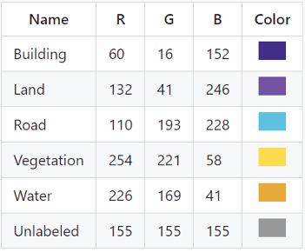
Figure 1: Classes and their corresponding RGB codes and colours

IV.3 MODEL TRAINING AND EVALUATION
The model is trained on the training dataset by repeatedly showing it images and their corresponding masks. For each image, the model makes a prediction, and its internal settings are adjusted to reduce the difference between its prediction and the actual mask. The training dataset is augmented, meaning that new, slightly modified versions of the images are created on-the-fly to increase the diversity of the training data. The training process continues for a set number of cycles (epochs).
U-Net Model Training
- U-Net Model Definition: The U-Net model was crafted by Olaf, Philipp, and Thomas in 2015. It is a convolutional neural network architecture specifically tailored for semantic image segmentation. It was originally developed for biomedical image analysis. The U Net’s ability to adeptly segment images with intricate structures has resulted in its widespread use in various fields, such as computer vision and satellite image analysis. It has a U-shaped architecture that includes a contracting and expanding path. 2) U-Net Model Architecture The U-Net architecture shown in Fig. 2. comprises several layers:
(i) Encoder: In the U-Net model, the encoder section comprises a sequence of convolutional layers, pooling layers, and ReLU activation functions. These layers systematically decrease the input image’s spatial dimensions while raising the quantity of feature maps. This progressive reduction aids in extracting hierarchical features from the input image.
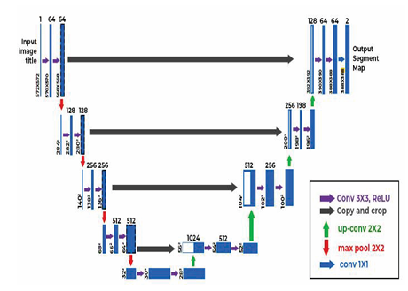
Figure 2: U-Net Architecture
(ii) Bottleneck: It is positioned at the core of the U-Net, typically containing multiple convolutional layers. It serves as a connection between the encoder and the decoder. This layer captures the most crucial features present in the input image.
(iii) Decoder: The U-Net’s decoder section is composed of up-convolutional layers and concatenation operations. This segment of the network gradually amplifies the spatial dimensions while decreasing the number of feature maps. Its role is to generate a segmentation map that aligns with the original input image.
(iv) Skip Connections: A distinctive aspect of the U-Net architecture is the incorporation of skip connections, linking the corresponding encoder and decoding layers. These connections enable the network to preserve high-resolution information from the encoder while integrating it with the context learned by the decoder. This feature is crucial for maintaining detailed information during the segmentation process.
(v) Output layer: The last layer in the U-Net typically consists of the convolutional layer using an activation function of sigmoid. This layer outputs the segmentation mask, a pixel by-pixel prediction indicating the probability of each pixel belonging to the target class of the input image. It enhances and refines the clarity of the images and makes them suitable for feature extraction.

Model Validation
The model is validated using the testing data, which consists of 16 images with their respective ground truth masks. A segmented image output is generated with the respective class labels assigned. To enhance the interpretability and facilitate further analysis, the segmented images are visually represented, with the class labels assigned to the segmented regions providing categorical identification of various elements present in the satellite imagery.

Performance Evaluation
The model’s performance and effectiveness are assessed by evaluating the generated segmented output with the ground truth mask of the satellite image using evaluation metrics. Evaluation metrics in machine learning serve as a quantitative measure to evaluate how effectively a machine learning model performs its designated task whether it is classification, regression, clustering, segmentation, natural language processing, or any other machine learning application. The selection of these metrics is contingent upon the unique characteristics and objectives of the specific problem at hand. The diversity of evaluation metrics reflects the variety of tasks within different domains. Choosing the right metrics for a specific task is crucial for aligning with the goals and characteristics of the task. Evaluation metrics include validation accuracy and Intersection Over Union (IoU) also known as Jaccard Index.

- RESULTS AND DISCUSSIONS
Visualization of Results
- Showcasing Results: The code selects a few images from the test dataset to demonstrate how well the model performs.
- Side-by-Side Comparison: For each selected image, the code displays three things side by side:
    - The original satellite image in Fig. 3, 4.
    - The "correct" land cover map (ground truth mask) in Fig. 5, 6.
    - The land cover map predicted by the model in Fig. 7, 8.
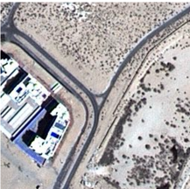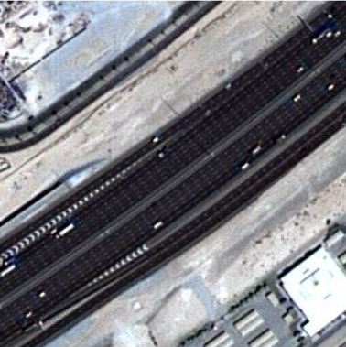
Figures 3, 4: Original Images

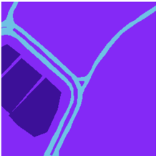
Figures 5, 6: Ground Truth Masks

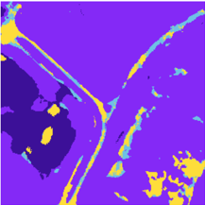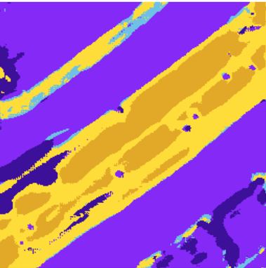
Figures 7, 8: Predicted Masks
- Color-Coded Maps: The land cover maps (both the ground truth and the model's prediction) are color-coded. Each colour represents a different type of land cover (e.g., blue for water, green for vegetation). This makes it easy to visually compare the model's prediction to the correct answer.
- Visual Inspection: By looking at these side-by-side comparisons, you can get a sense of how well the model is performing. You can see if the model is accurately identifying different land cover types and if the boundaries between different regions are well-defined.
In addition to the visual inspection of individual images, the implementation also generates graphs to track the model's performance over time during training. These graphs provide valuable information about how well the model is learning and whether it is overfitting the training data.
- Loss Graph: This graph shows the training and validation loss over each training cycle (epoch). The loss is a measure of how poorly the model is performing on the training and validation datasets. A lower loss indicates better performance. The training loss shows how well the model is fitting the training data, and the validation loss shows how well the model is generalizing to new, unseen data. If the training loss is much lower than the validation loss, it may indicate that the model is overfitting the training data (Fig. 9).
- Accuracy Graph (If Available): If the code includes accuracy as a performance metric, this graph shows the training and validation accuracy over each training cycle (epoch). The accuracy is the percentage of pixels that are correctly classified. A higher accuracy indicates better performance. Similar to the loss graph, the training accuracy shows how well the model is fitting the training data, and the validation accuracy shows how well the model is generalizing to new, unseen data (Fig. 10).

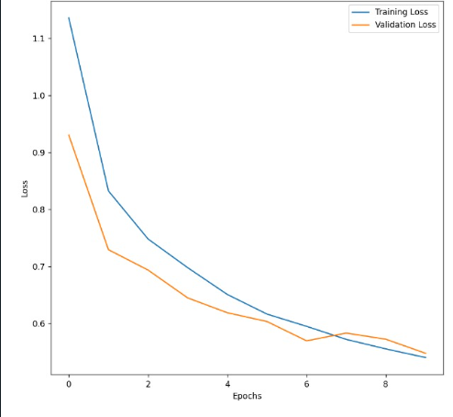
Figure 9: Training and Validation Loss

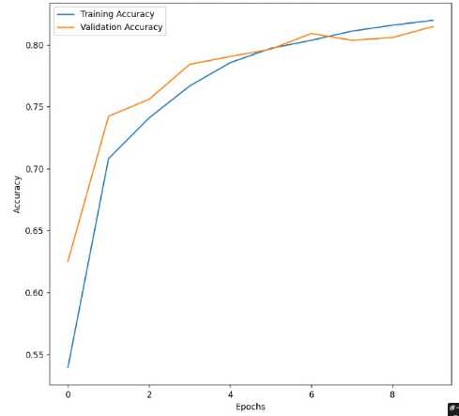
Figure 10: Training and Validation Accuracy

- CONCLUSION
This research successfully implemented a U-Net architecture with a Spatial Pyramid Pooling (SPP) layer at its bottleneck for semantic segmentation of satellite imagery. The model's performance was evaluated across multiple datasets, revealing key insights into its capabilities and limitations. On the OPTIMAL-31 dataset, the model achieved high accuracy, reaching up to 98%. However, this high accuracy was accompanied by a tendency for the model to overfit the training data, indicating that it may not generalize well to unseen data. In contrast, when applied to datasets from DeepGlobe and Sentinel vendors, the model achieved a lower accuracy of up to 88.9% but demonstrated a reduced susceptibility to overfitting. This suggests a trade-off between accuracy and generalization depending on the dataset characteristics. The integration of the SPP layer, in conjunction with appropriate data augmentation techniques, resulted in a significant improvement in segmentation accuracy. Specifically, a positive change of 10% to 15% in accuracy was observed compared to a U-Net model without the SPP layer. This underscores the effectiveness of SPP in capturing multi-scale contextual information, leading to more accurate segmentation results, particularly when combined with data augmentation strategies that enhance the model's robustness and generalization ability.

- REFERNENCES

- K. Pushpa Rani, Pogula Sreedevi, C. Dastagiriah, K. Sreenivas Rao, G. V. Subbaraju, Jasti Padmavathi. (2024). Land Cover Extraction from Satellite Imagery using U-Net Model. 2024 11th International Conference on Computing for Sustainable Global Development (INDIACom).

- Priit Ulmas, Innar Liiv. (2020). Segmentation of Satellite Imagery using U-Net Models for Land Cover Classification. IEEE ACCESS, Computer Vision and Pattern Recognition.

- Dhanishtha Patil, Komal Patil, Rutuja Nale, Sangita Chaudhari. (2022). Semantic Segmentation of Satellite Images using Modified U-Net. 2022 IEEE Region 10 Symposium (TENSYMP).

- Hua Zhang, Zhengang Jiang, Guoxun Zheng, Xuekun Yao. (2023). Semantic Segmentation of High-Resolution Remote Sensing Images with Improved U-Net Based on Transfer Learning. International Journal of Computational Intelligence Systems.

- Alexander Rakhlin, Alex Davydow, Sergey Nikolenko. (2018). Land Cover Classification from Satellite Imagery With U-Net and Lov´ asz-Softmax Loss. 2018 IEEE/CVF Conference on Computer Vision and Pattern Recognition Workshops.

- Vaishnavi Patil; Zaware Sarika N.; Rajlaxmi Bhosale; Nikita Shetty; Vama Shah. (2024). Land Cover Mapping Using Semantic Segmentation Models. 2023 7th International Conference On Computing, Communication, Control And Automation (ICCUBEA).

- Muhammad Talha, Farrukh A. Bhatti, Sajid Ghuffar, Hamza Zafar. (2023). ADU-Net: Semantic segmentation of satellite imagery for land cover classification. Advances in Space Research, (Volume 72, Issue 5).

- Shreesha S, Hrishikesh Singh Yadav Priyanshu Panchal Divyanshu Manawat Girisha S. (2023). Self-Attention in U-Net for Semantic Segmentation of Low-Resolution SAR Images. CVIPPR '23: Proceedings of the 2023 Asia Conference on Computer Vision, Image Processing and Pattern Recognition.
- Mandicou BA, Pape Ibrahima THAIM, Etienne DELAY, Charles Abdoulaye NGOM, Idy DIOP, Alassane BAH. (2024). Deep Learning-based Land Use and Land Cover Changes Detection from Satellite Imagery: a case study of the city of Richard Toll. ICMVA 2024.

- Bakht Alam Khan, Jin-Woo Jung. (2024). Semantic Segmentation of Aerial Imagery Using U-Net with Self-Attention and Separable Convolutions. Appl. Sci. 2024.

- P. Anilkumar and P. Venugopal, "A Survey on Semantic Segmentation of Aerial Images using Deep Learning Techniques," 2021 Innovations in Power and Advanced Computing Technologies (i-PACT).

- Raghav Dahiya, Shikhar Saini, Dr. Sanatan Ratna, Mr. Manish Kumar Ojha. (2024). Satellite Image Segmentation Using U-Net. 2024 15th International Conference on Computing Communication and Networking Technologies (ICCCNT).

- Pengbin Zhang, Yinghai Ke, Zhenxin Zhang, Mingli Wang, Peng Li, Shuangyue Zhang. (2018). Urban Land Use andLandCover Classification Using Novel Deep Learning Models Based on High Spatial Resolution Satellite Imagery. Sensors 2018.

- Anastasios Temenos, Eftychios Propapadakis, Anastasios Doulamis, Nikos Temenos. (2021). Building Extraction from RGB Satellite Images using Deep Learning: A U-Net Approach. In The 14th Pervasive Technologies Related to Assistive Environments Conference (PETRA 2021).

- Yong Wang, Dongfang Zhang and Guangming Dai. (2020). Classification of High-Resolution Satellite Images Using Improved U–Net. International Journal of Applied Mathematics and Computer Science.

